**Data Collection & Exploration**

* **Data Needs and Sources**
* Course Introduction
* Choosing Predictive Data
* Timing and Quanlity of Data

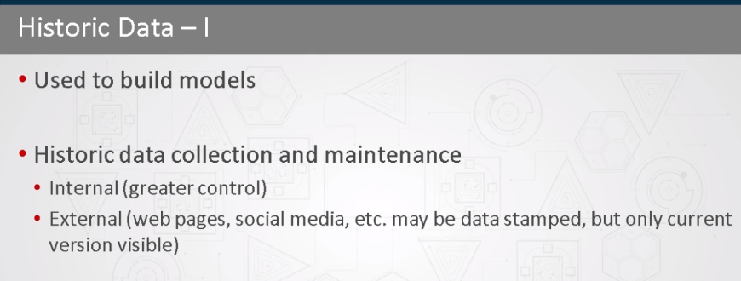

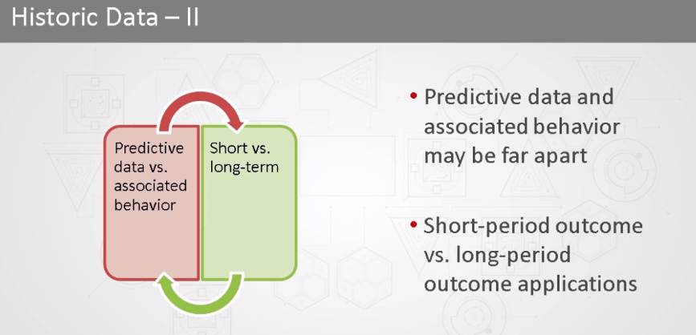

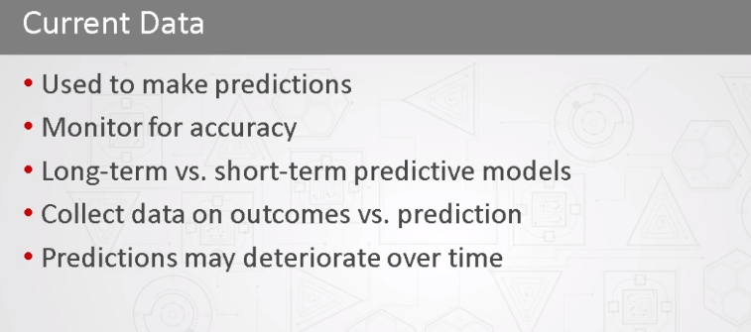

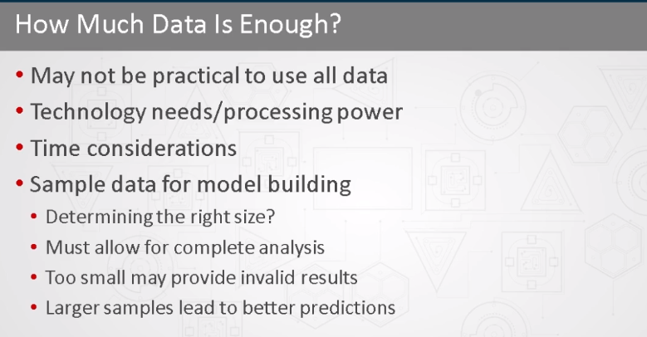

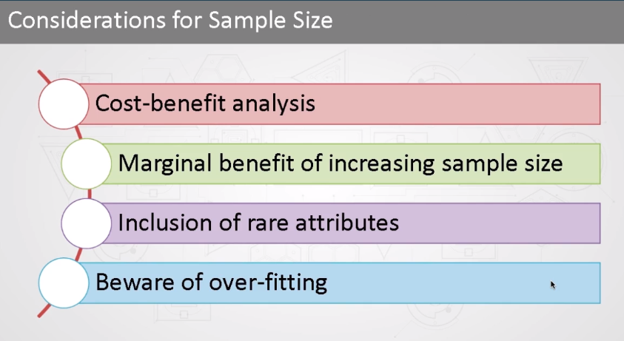

* Common Data Sources

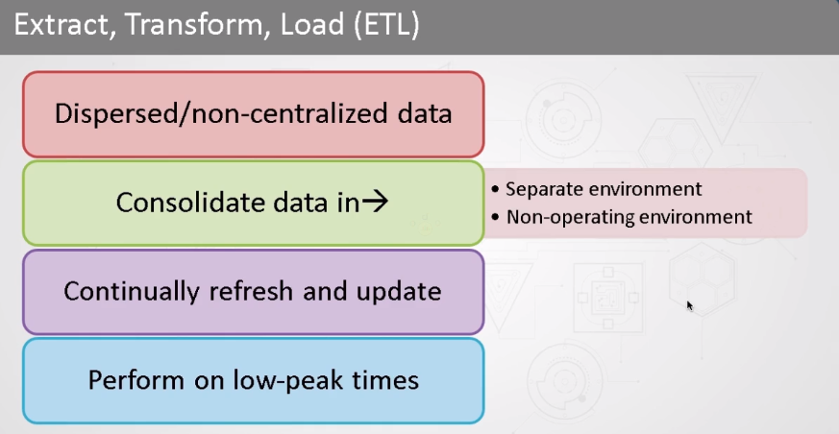

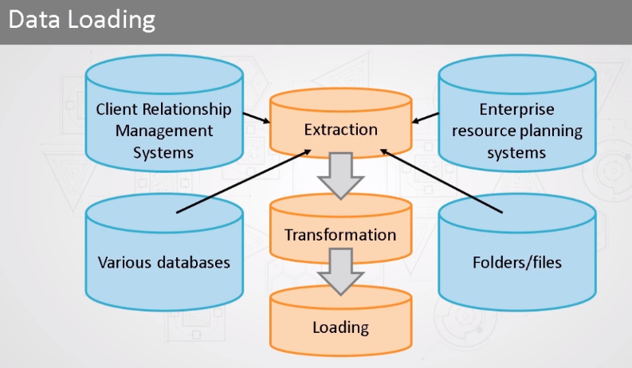

* Extract, Transform, and Load Data
* Data Warehousing and Data Marts
* Relational Database Management System and Hadoop
* **Data Collection and Exploration**
* Data Collection Considerations
* Data Collection Strategy
* Data Exploration Objectives
* Data Exploration Roadmap
* **Course Test**